Refactoring documentation for “Poker” by team “Breadfruit”



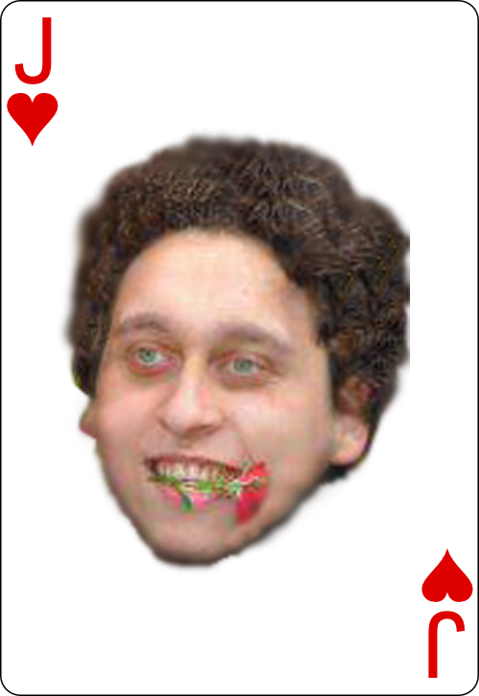



1. Redesigned the project structure:
   * Extracted repeated code in methods
   * Extracted each class in a separate file and named them properly
   * Created new classes and distributed methods accordingly
   * Renamed the main class to PlayGame
2. Created enumarables for:
   * Card type
   * Card suit
3. Reformatted the source code:
   * Removed all unneeded empty lines, and placed new ones where needed
   * Removed redundant code
   * Split lines that contained several statements into several lines
   * Fixed character casing
   * Formatted the curly braces according to the best practices for the C# language
4. Renamed variables
   * bb - bigBlind
   * bRaise – botRaise
   * c1 - cardOne
   * Replaced all numbers written with digits with words - Bot1 – botOne
   * Removed all unused variables
5. Renamed methods
   * Rules – GameRulesCreator
   * rFourOfAKind - rulesFourOfAKind
6. Introduced constants:
   * DefaultStartingChips = 10000
   * LastRound = 4
7. Extracted methods
8. Created classes
   * CardFactory, Dealer, Winner, Card, CardsCollection, Hand, Human, Player, Bot, Rules
9. Removed regions
10. Created unit tests